Listener Issues

Open the Services app to check that the Oracle Listener is running.
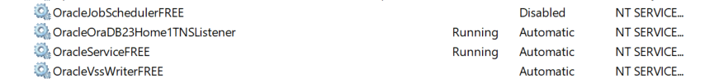

To start the listener, right click and select Start from the menu.

Check Listener status, open the Command prompt and enter the command
lsnrctl status
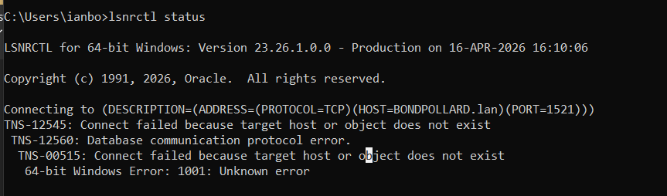

Note the connection message above shows HOST=BONDPOLLARD.lan
Connecting to (DESCRIPTION=(ADDRESS=(PROTOCOL=TCP)(HOST=BONDPOLLARD.lan)(PORT=1521)))

This is incorrect, it should be BONDPOLLARD (as specified by localhost).

To check the correct value for localhost, ping it from the command prompt:
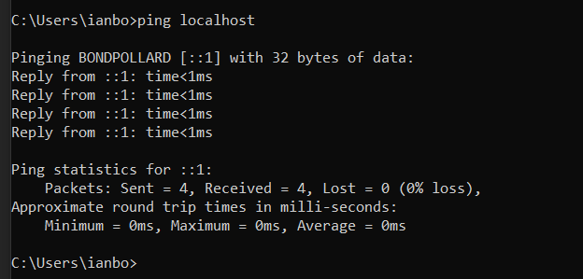

Check that HOST = localhost in listener.ora and tnsnames.ora

C:\app\ianbo\product\26ai\dbhomefree\network\admin

listener.ora
# listener.ora Network Configuration File: C:\app\ianbo\product\26ai\dbhomeFree\NETWORK\ADMIN\listener.ora
# Generated by Oracle configuration tools.

DEFAULT_SERVICE_LISTENER = FREE

LISTENER =
(DESCRIPTION_LIST =
(DESCRIPTION =
(ADDRESS = (PROTOCOL = TCP)(HOST = BONDPOLLARD.lan)(PORT = 1521))
(ADDRESS = (PROTOCOL = IPC)(KEY = EXTPROC1521))
)
)

Change HOST name:
(ADDRESS = (PROTOCOL = TCP)(HOST = BONDPOLLARD.lan)(PORT = 1521))
To:
(ADDRESS = (PROTOCOL = TCP)(HOST = localhost)(PORT = 1521))

Do the same with tnsnames.ora, make sure HOST = localhost:
# tnsnames.ora Network Configuration File: C:\app\ianbo\product\26ai\dbhomeFree\NETWORK\ADMIN\tnsnames.ora
# Generated by Oracle configuration tools.

FREE =
(DESCRIPTION =
(ADDRESS = (PROTOCOL = TCP)(HOST = localhost)(PORT = 1521))
(CONNECT_DATA =
(SERVER = DEDICATED)
(SERVICE_NAME = FREE)
)
)

LISTENER_FREE =
(ADDRESS = (PROTOCOL = TCP)(HOST = localhost)(PORT = 1521))

Re-start the listener in services, and check the status again:
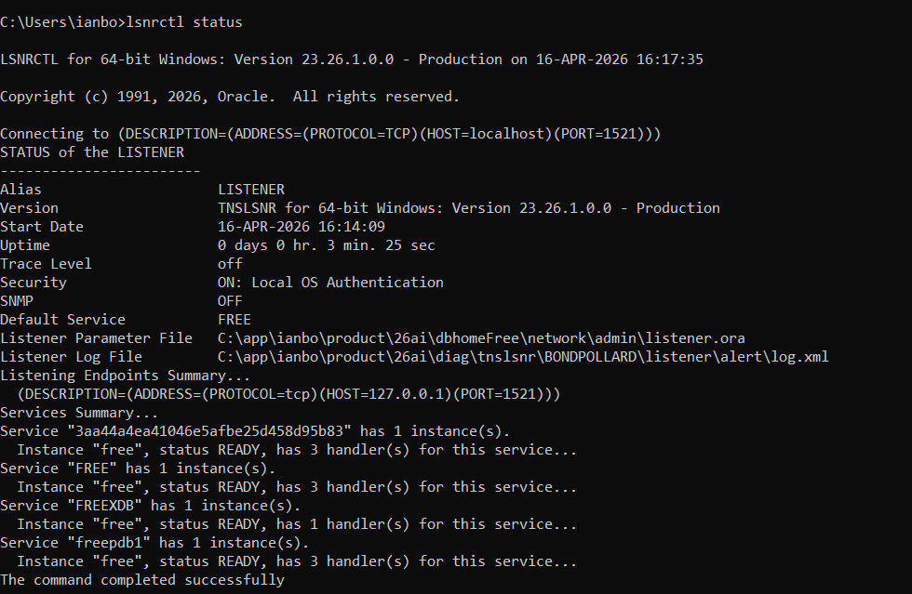

APEX

Listener Issues

Run script ..\admin\fix_listener.sql

sqlplus / as sysdba
SQL>show parameter local_listener;
SQL>alter system set local_listener ='(ADDRESS=(PROTOCOL=TCP)(HOST=localhost)(PORT=1521))'scope=both;
SQL>alter system register;
SQL>show parameter local_listener;

ORDS Unable to connect to database – Password Expired

When you try to login to APEX (click link)
http://localhost:8080/ords/r/apex/workspace-sign-in/oracle-apex-sign-in?clear=SESSION&session=16131270181688

You get an error:
ORDS was unable to make a connection to the database. The database user specified by db.username configuration setting is expired. The connection pool named: |default|lo| had the following error(s): ORA-28001: the password has expired docs.oracle.com/error-help/db/ora-28001/

This is caused by the APEX ADMIN password expiring.

Solution

Open the command prompt.
Change directory to the apex installation path:
C:\>cd c:\app\apex
C:\app\apex>sqlplus / as sysdba

SQL> alter session set container = FREEPDB1;
Session altered.
SQL> @apxchpwd.sql
...set_appun.sql

This script can be used to change the password of an Oracle APEX
instance administrator. If the user does not yet exist, a user record will be
created.

Enter the administrator's username [ADMIN]
User "ADMIN" exists.
Enter ADMIN's email [ian1bond@gmail.com]
Enter ADMIN's password []

Enter a new password for ADMIN (must be >=6 characters, mix of upper and lower case, include number and special characters.

Restart Apache.
